USA Wrestling Membership

Log on: http://www.usawmembership.com

NOTE: Even if you have had a USA card before you will need to create a new account to access your records.

Select Create Free Account

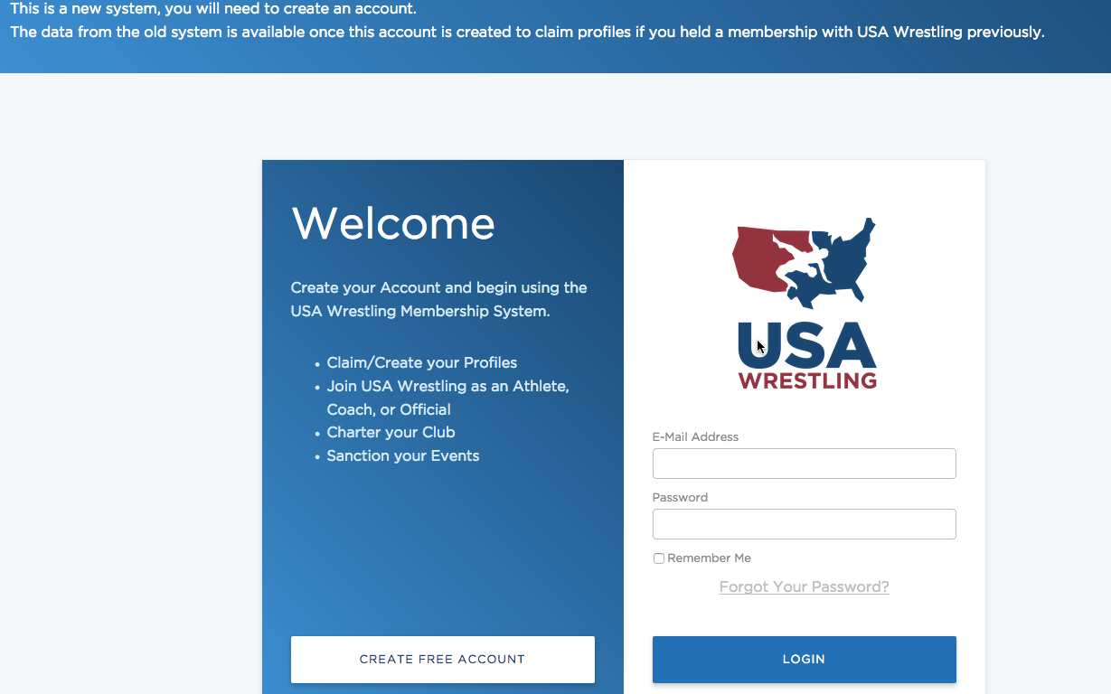

Parents will need to create the accounts in their name. Wrestlers must be 13 years or old to create their own account.

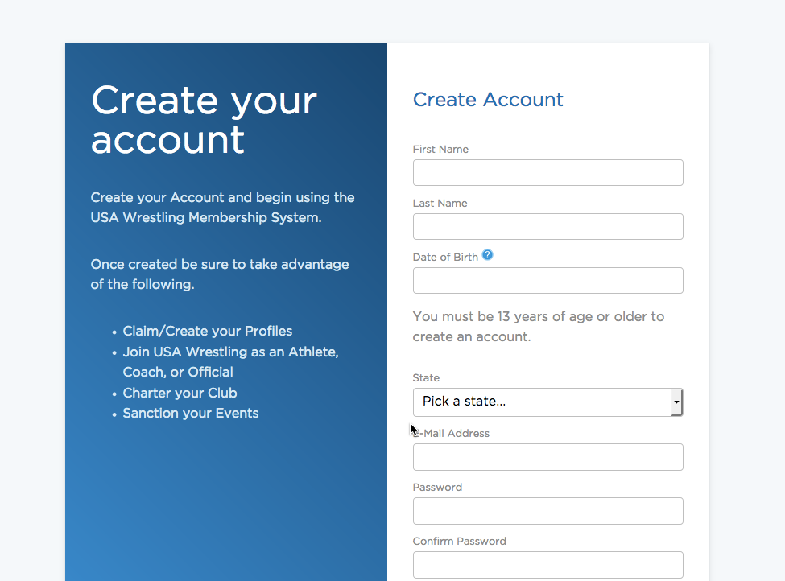

Select Profile from main menu
Create a profile for yourself then one for each wrestler.

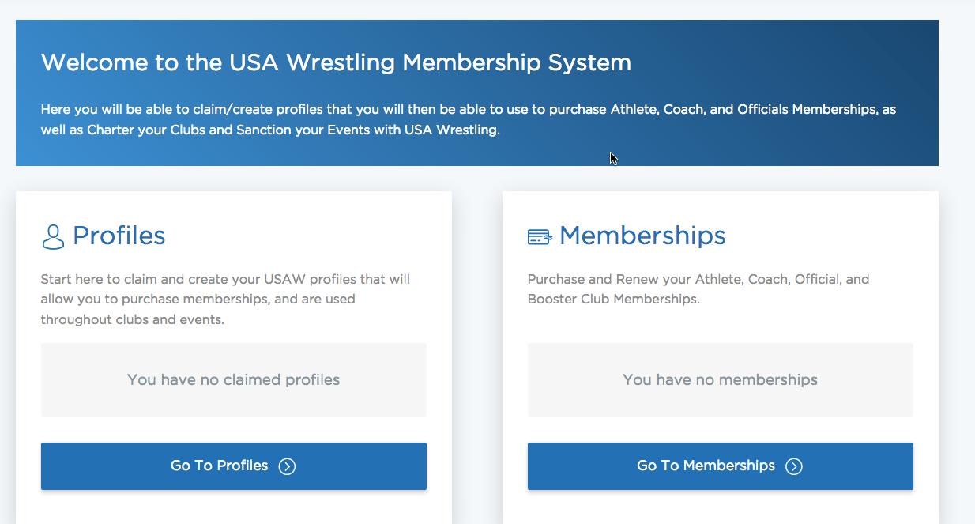

Select MEMBERSHIP from main menu

SELECT PURCHASE MEMBERSHIP

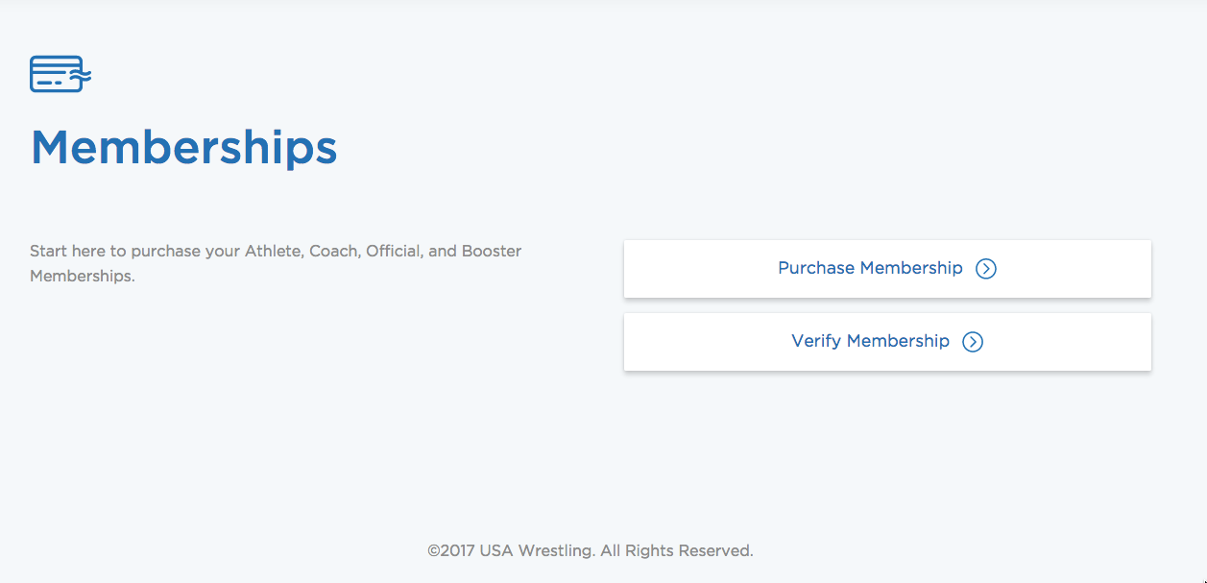

Select SEARCH PROFILES This is only for wrestlers that have had USA cards before.

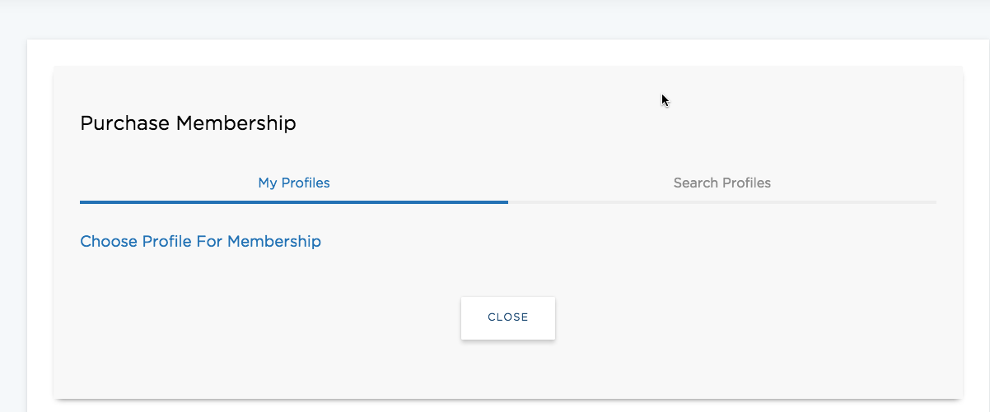

Enter your wrestler’s information here and select search

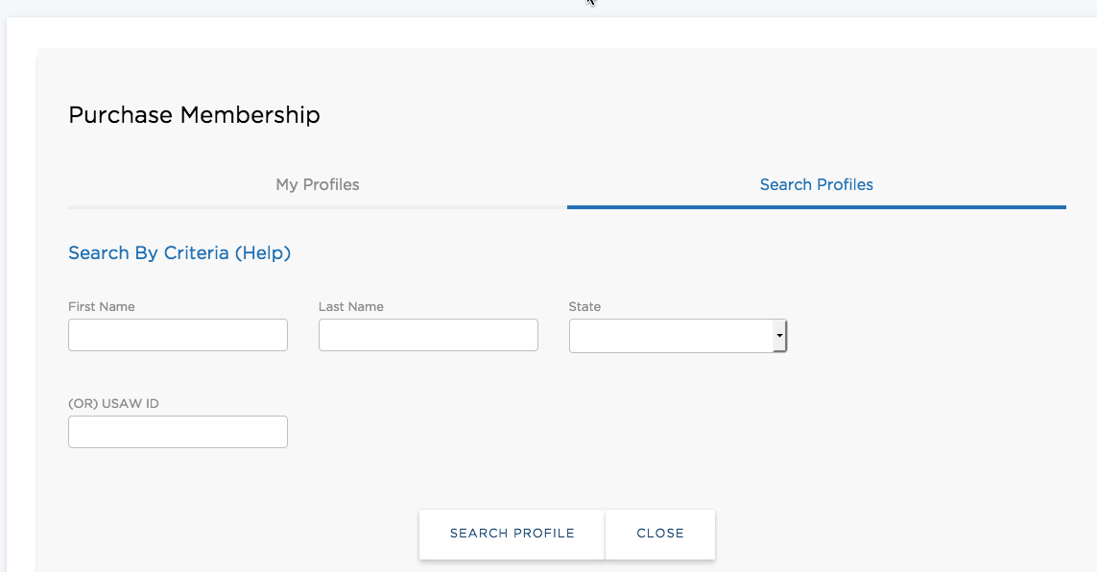

Your wrestler’s information will display. Then select PURCHASE

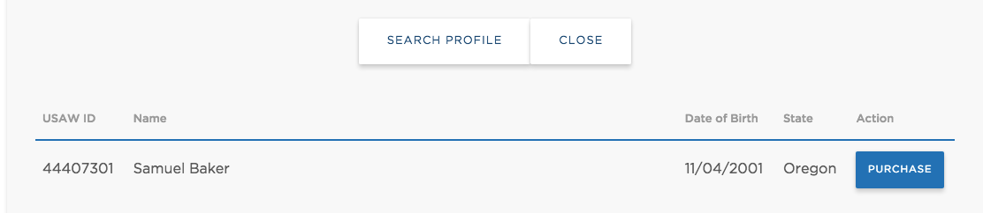

Select ATHLETIC MEMBERSHIP and $46 – ATHLETIC - Tradit

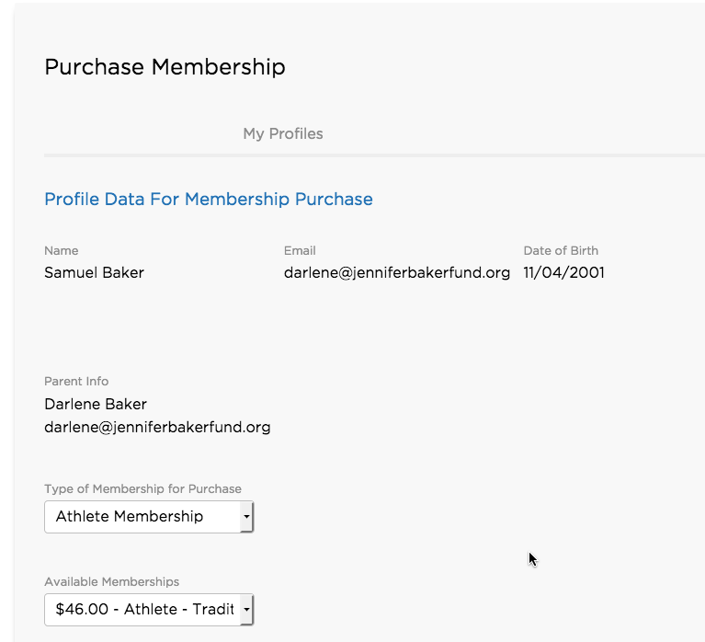

All wrestlers will be required to have USA cards. This will also allow wrestlers to enter to USA tournaments. The cost is $46 and the membership is good through August 2018.

